My Isekai Data Adventure
knitr::opts_chunk$set(echo = TRUE)
setwd("C://Users//joshj//My Drive//Scranton//Other//Data contest//My Isekai Data Adventure")
#data prep
library(readxl)
d1 <- read_excel("battle.xlsx")
d2 <- read_excel("hocus_pocus.xlsx")
d1$kills<-as.integer(d1$kills)
d1$knight<-factor(d1$knight)
d1$battalion<-factor(d1$battalion)
#1. The king must reward the knight who had the most kills in the recent battle. This will create an incentive for future battles. Who was the knight with the greatest number of kills in the battle data?
killsord<-d1[order(d1$kills, decreasing = TRUE), ]
killsord[1, 1]
## # A tibble: 1 × 1
## knight
## <fct>
## 1 herculean_elephant
#2. The king decides to also reward the battalion with the most kills.
#2a.Which battalion should be rewarded?
battalion_total_kills <- aggregate(kills ~ battalion, data = d1, FUN = sum)
battalion_kills_ordered <- battalion_total_kills[order(battalion_total_kills$kills, decreasing = TRUE), ]
top_battalion <- battalion_kills_ordered[1, ]
top_battalion
## battalion kills
## 2 Reapers 6192
#2b. What battalion should be rewarded based on the number of kills per knight per battalion (meaning, which battalion has the highest rate of kills)?
battalion_knight_counts <- aggregate(knight ~ battalion, data = d1, FUN = function(x) length(unique(x)))
battalion_summary <- merge(battalion_total_kills, battalion_knight_counts, by = "battalion")
battalion_summary$kills_rate <- battalion_summary$kills / battalion_summary$knight
battalion_rate_ordered <- battalion_summary[order(battalion_summary$kills_rate, decreasing = TRUE), ]
top_rate_battalion <- battalion_rate_ordered[1, ]
top_rate_battalion_name <- battalion_rate_ordered[1, "battalion"]
top_rate_battalion_name
## [1] Wolf
## Levels: Orlock Reapers Slayers Wolf
#3. The great Dio is forming an elite band of three knights. Knights need to have high stats across the board, so there is no preference for strength versus dexterity, for example. Based on their strength, dexterity, and constitution, which three knights do you choose and why?
d1$total_stats <- rowSums(d1[, c("strength", "dexterity", "constitution")])
knights_by_total_stats_ordered <- d1[order(d1$total_stats, decreasing = TRUE), ]
top_3_knights <- knights_by_total_stats_ordered[1:3, "knight"]
top_3_knights_rows <- knights_by_total_stats_ordered[1:3, ]
top_3_knights_rows
## # A tibble: 3 × 8
## knight battalion dash kills strength dexterity constitution total_stats
## <fct> <fct> <dbl> <int> <dbl> <dbl> <dbl> <dbl>
## 1 seaborne_ai… Reapers 14.1 25 151. 127. 157. 435.
## 2 charismatic… Reapers 9.67 23 151. 132. 139. 423.
## 3 chromatnic_… Slayers 15.3 21 111. 146. 164. 421.
#4. Create a pairwise of dash, strength, dexterity, and constitution? Meaning, there should be correlation coefficients and scatterplots in a single plot image.
#a. First produce the plot.
library(GGally)
## Loading required package: ggplot2
## Registered S3 method overwritten by 'GGally':
## method from
## +.gg ggplot2
battle_subset <- d1[, c("dash", "strength", "dexterity", "constitution")]
pairwise <- ggpairs(battle_subset,
title = "Pairwise Plot: Strength, Dexterity, Constitution",
upper = list(continuous = wrap("cor", size = 4)),
lower = list(continuous = wrap("points", alpha = 0.6, size = 1)),
diag = list(continuous = wrap("densityDiag", alpha = 0.6)))
pairwise
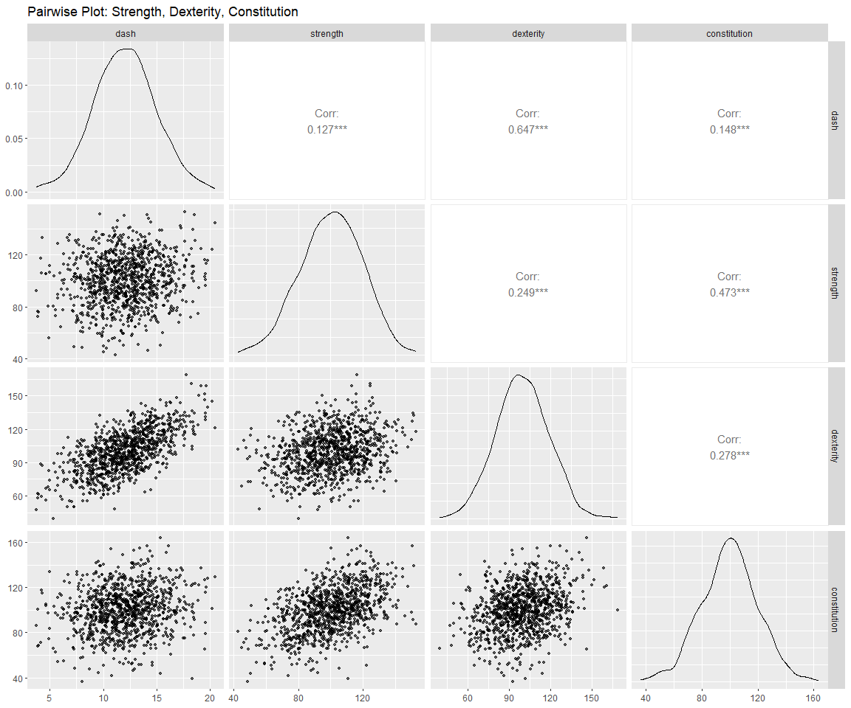
#b. What is the strongest correlation?
#.647 which is between dash and dexterity
#c. Why do you think that is the strongest correlation?
#part of your dexterity is speed. Since dash is dash speed, it makes sense that these would be particularly strongly related.
#5. 5. Our elder mage has worked tirelessly to create a catalog of spells. Can you tell the great Dio, how many spells there are for each caster_class? Have you no mercy! This amount of numbers overwhelms me. I have heard tales of a great city known as “Cleveland”. Yes, that’s the ticket. Make a Cleveland dot plot of that data!
library(tidyr)
library(dplyr)
##
## Attaching package: 'dplyr'
## The following objects are masked from 'package:stats':
##
## filter, lag
## The following objects are masked from 'package:base':
##
## intersect, setdiff, setequal, union
spells_split <- d2 %>%
separate_rows(caster_class, sep = ",\\s*")
spell_counts <- spells_split %>%
count(caster_class, sort = TRUE)
spell_counts
## # A tibble: 68 × 2
## caster_class n
## <chr> <int>
## 1 wizard 310
## 2 sorcerer 193
## 3 druid 151
## 4 bard 143
## 5 warlock 119
## 6 cleric 114
## 7 artificer 78
## 8 ranger 71
## 9 paladin 53
## 10 paladin: ancients 12
## # ℹ 58 more rows
caster_spell_plot <- ggplot(spell_counts, aes(x = n, y = reorder(caster_class, n))) +
geom_point(size = 4, color = "steelblue") + # Add points for the counts
labs(
title = "Spell Counts by Caster Class",
x = "Number of Spells",
y = "Caster Class"
) +
theme_minimal(base_size = 14) +
theme(
plot.title = element_text(hjust = 0.5, face = "bold"),
axis.text.y = element_text(face = "bold", size = 10),
panel.grid.major.y = element_blank(),
panel.grid.minor.y = element_blank(),
panel.grid.major.x = element_line(color = "grey80", linetype = "dotted"),
panel.grid.minor.x = element_blank()
) +
geom_text(aes(label = n), hjust = -0.8, size = 3, color = "darkslategrey") +
scale_x_continuous(expand = expansion(add = c(0.5, 1.5)))
caster_spell_plot
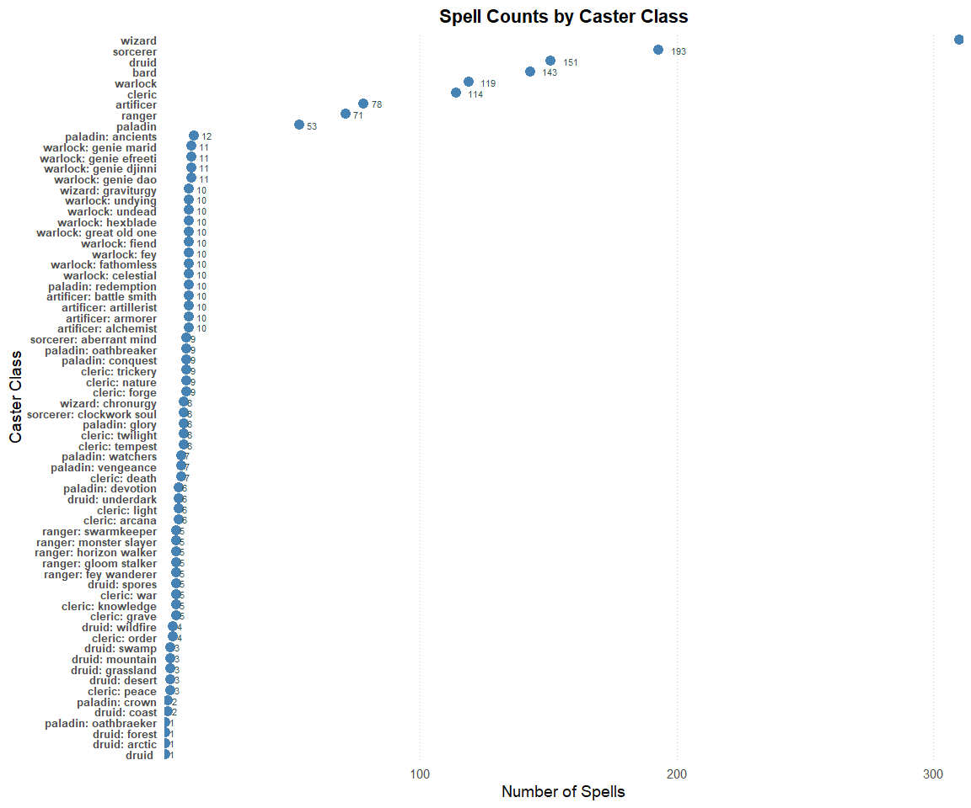
#6. How many total spells of level 7, 8, and 9, can a wizard cast?
wizard_level_count <- spells_split %>%
filter(caster_class == "wizard", spell_level %in% c("level 7", "level 8", "level 9")) %>%
count()
wizard_level_count
## # A tibble: 1 × 1
## n
## <int>
## 1 54
#7. We need to know about the number of spells that each school can cast. How many spells can each school cast? Put these values in a table so our feeble magick minded brains can understand.
library(knitr)
## Warning: package 'knitr' was built under R version 4.4.3
school_counts <- d2 %>%
count(spell_school, sort = TRUE)
kable(school_counts,
col.names = c("Spell School", "Number of Spells"),
caption = "Number of Spells per School of Magick")
Number of Spells per School of Magick
Spell School | Number of Spells
Evocation | 95
Conjuration | 90
Transmutation | 88
Abjuration | 53
Enchantment | 42
Necromancy | 39
Divination | 34
Illusion | 31
#8. The great Dio must better understand which physical stat is the best predictor of kills. That way, we can level grind some of the next batch of soldiers to maximize that stat. Build a model that predicts kills, using the predictors strength, dexterity, and constitution. Make sure you understand that kills is likely to follow a Poisson distribution. What is the parameter estimate for the variable with the strongest relationship?
var(d1$kills)/mean(d1$kills)
## [1] 1.006505
#VMR looks good
library(VGAM)
## Loading required package: stats4
## Loading required package: splines
mod.pois1 <- glm(kills~ strength + dexterity + constitution, data = d1)
mod.pois1
##
## Call: glm(formula = kills ~ strength + dexterity + constitution, data = d1)
##
## Coefficients:
## (Intercept) strength dexterity constitution
## 1.21900 0.08222 0.06137 0.02148
##
## Degrees of Freedom: 999 Total (i.e. Null); 996 Residual
## Null Deviance: 17820
## Residual Deviance: 11900 AIC: 5324
summary(mod.pois1)
##
## Call:
## glm(formula = kills ~ strength + dexterity + constitution, data = d1)
##
## Coefficients:
## Estimate Std. Error t value Pr(>|t|)
## (Intercept) 1.218998 0.765520 1.592 0.111617
## strength 0.082223 0.006484 12.682 < 2e-16 ***
## dexterity 0.061370 0.006029 10.180 < 2e-16 ***
## constitution 0.021481 0.006299 3.410 0.000675 ***
## ---
## Signif. codes: 0 '***' 0.001 '**' 0.01 '*' 0.05 '.' 0.1 ' ' 1
##
## (Dispersion parameter for gaussian family taken to be 11.94561)
##
## Null deviance: 17824 on 999 degrees of freedom
## Residual deviance: 11898 on 996 degrees of freedom
## AIC: 5324.2
##
## Number of Fisher Scoring iterations: 2
#strength is the variable with the highest value. Since they are all on the same scale, there is the largest change kills with strength
#a. What variable has the strongest relationship?
mod.pois.s <- glm(kills~ strength, data = d1)
mod.pois.s
##
## Call: glm(formula = kills ~ strength, data = d1)
##
## Coefficients:
## (Intercept) strength
## 6.9121 0.1078
##
## Degrees of Freedom: 999 Total (i.e. Null); 998 Residual
## Null Deviance: 17820
## Residual Deviance: 13490 AIC: 5446
mod.pois.d <- glm(kills~ dexterity, data = d1)
mod.pois.d
##
## Call: glm(formula = kills ~ dexterity, data = d1)
##
## Coefficients:
## (Intercept) dexterity
## 8.91055 0.08839
##
## Degrees of Freedom: 999 Total (i.e. Null); 998 Residual
## Null Deviance: 17820
## Residual Deviance: 14990 AIC: 5551
mod.pois.c <- glm(kills~ constitution, data = d1)
mod.pois.c
##
## Call: glm(formula = kills ~ constitution, data = d1)
##
## Coefficients:
## (Intercept) constitution
## 10.24365 0.07513
##
## Degrees of Freedom: 999 Total (i.e. Null); 998 Residual
## Null Deviance: 17820
## Residual Deviance: 15560 AIC: 5588
library(AICcmodavg)
##
## Attaching package: 'AICcmodavg'
## The following object is masked from 'package:VGAM':
##
## AICc
modlist<- list(mod.pois.s, mod.pois.d, mod.pois.c)
mod.names <- c("mod.pois.s", "mod.pois.d", "mod.pois.c")
aictab(cand.set = modlist, modnames = mod.names)
##
## Model selection based on AICc:
##
## K AICc Delta_AICc AICcWt Cum.Wt LL
## mod.pois.s 3 5445.53 0.00 1 1 -2719.75
## mod.pois.d 3 5551.14 105.61 0 1 -2772.56
## mod.pois.c 3 5588.37 142.84 0 1 -2791.17
bictab(cand.set = modlist, modnames = mod.names)
##
## Model selection based on BIC:
##
## K BIC Delta_BIC BICWt Cum.Wt LL
## mod.pois.s 3 5460.23 0.00 1 1 -2719.75
## mod.pois.d 3 5565.84 105.61 0 1 -2772.56
## mod.pois.c 3 5603.07 142.84 0 1 -2791.17
#if we build separate models of each of those predictors and compare them, similarly we see that the strength model has the lowest deviance given the number of parameters
#b. For this effect, what is the change in the incidence rate or number of events for a one-unit increase in the predictor, holding the other predictors constant (i.e., what is the incidence rate ratio for that effect)?
exp(coef(mod.pois1))
## (Intercept) strength dexterity constitution
## 3.383795 1.085698 1.063292 1.021713
# 1.085698
#c. What about for a 10-unit increase?
1.085698^10
## [1] 2.275571
#2.275571
#9. Hark! Although that model is mighty indeed, the great Dio demands that we have a parameter estimate given the data. Thus, build the same model, but make it Bayesian! Use weakly informative priors. To display the effects from the model, use a Clevland dot plot. Do not include the intercept.
library(brms)
## Warning: package 'brms' was built under R version 4.4.3
## Loading required package: Rcpp
## Loading 'brms' package (version 2.22.0). Useful instructions
## can be found by typing help('brms'). A more detailed introduction
## to the package is available through vignette('brms_overview').
##
## Attaching package: 'brms'
## The following objects are masked from 'package:VGAM':
##
## acat, cratio, cumulative, dfrechet, dirichlet, exponential,
## frechet, geometric, lognormal, multinomial, negbinomial, pfrechet,
## qfrechet, rfrechet, s, sratio
## The following object is masked from 'package:stats':
##
## ar
mod.pois1.bayes<-brm(kills~ strength + dexterity + constitution,
data = d1,
family = poisson(),
sample_prior=TRUE,
save_pars = save_pars(all = TRUE),
iter=10000,
cores = 8, chains = 4)
## Compiling Stan program...
## Start sampling
#diagnostics
pp_check(mod.pois1.bayes, type = "ecdf_overlay")
## Using 10 posterior draws for ppc type 'ecdf_overlay' by default.
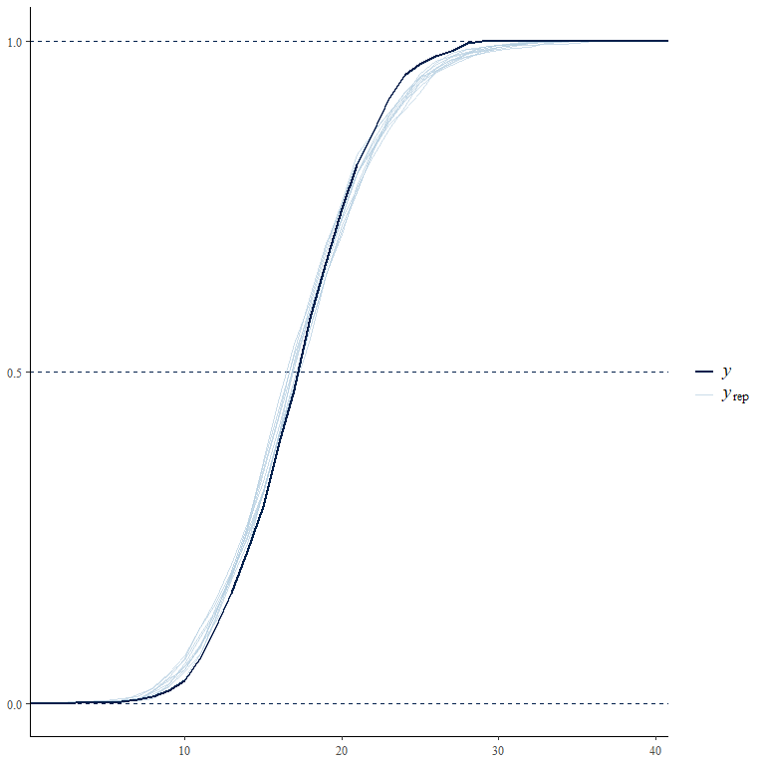
pp_check(mod.pois1.bayes, type = "dens_overlay")
## Using 10 posterior draws for ppc type 'dens_overlay' by default.
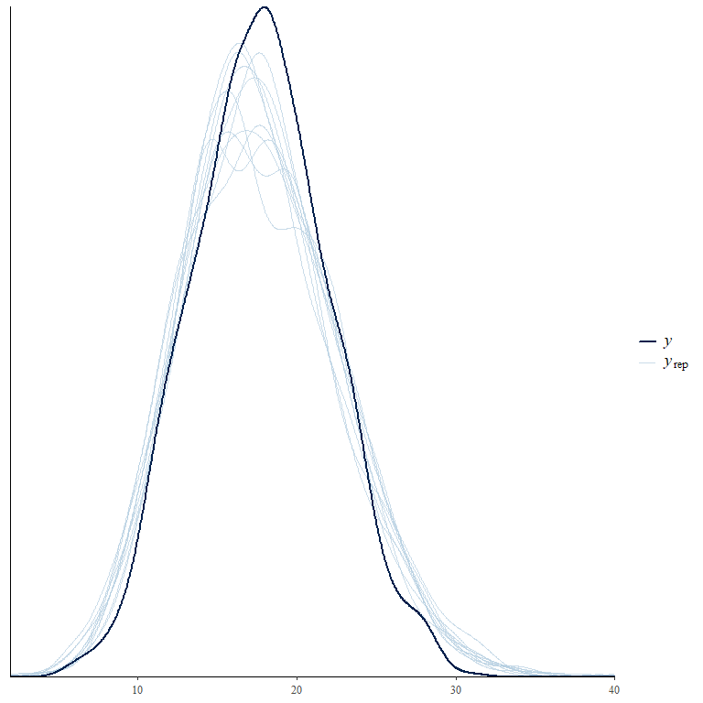
#looks good
plot(mod.pois1.bayes)
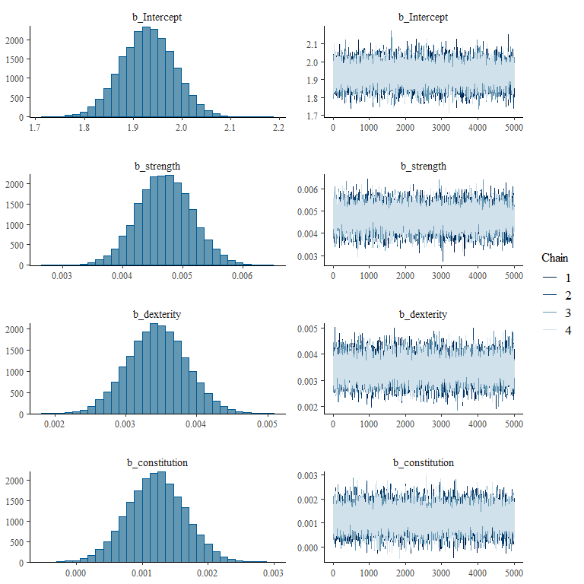
#chains look good. parameters are as expected.
print(summary(mod.pois1.bayes), digits=5)
## Family: poisson
## Links: mu = log
## Formula: kills ~ strength + dexterity + constitution
## Data: d1 (Number of observations: 1000)
## Draws: 4 chains, each with iter = 10000; warmup = 5000; thin = 1;
## total post-warmup draws = 20000
##
## Regression Coefficients:
## Estimate Est.Error l-95% CI u-95% CI Rhat Bulk_ESS Tail_ESS
## Intercept 1.92976 0.05411 1.82362 2.03524 0.99992 19488 14948
## strength 0.00470 0.00045 0.00382 0.00560 1.00019 18972 15447
## dexterity 0.00344 0.00042 0.00263 0.00426 1.00019 22410 15544
## constitution 0.00121 0.00043 0.00037 0.00207 1.00013 19841 16036
##
## Draws were sampled using sampling(NUTS). For each parameter, Bulk_ESS
## and Tail_ESS are effective sample size measures, and Rhat is the potential
## scale reduction factor on split chains (at convergence, Rhat = 1).
plot.dist <-mcmc_plot(mod.pois1.bayes, variable = c("^b_strength", "^b_dexterity", "^b_constitution"), regex = TRUE)
library(ggplot2)
plot.dist<-plot.dist + theme_minimal() +
scale_y_discrete(labels=c("b_strength"="Strength",
"b_dexterity"="Dexterity",
"b_constitution"="Constitution")) +
theme(text = element_text(size = 15))
## Scale for y is already present.
## Adding another scale for y, which will replace the existing scale.
plot.dist
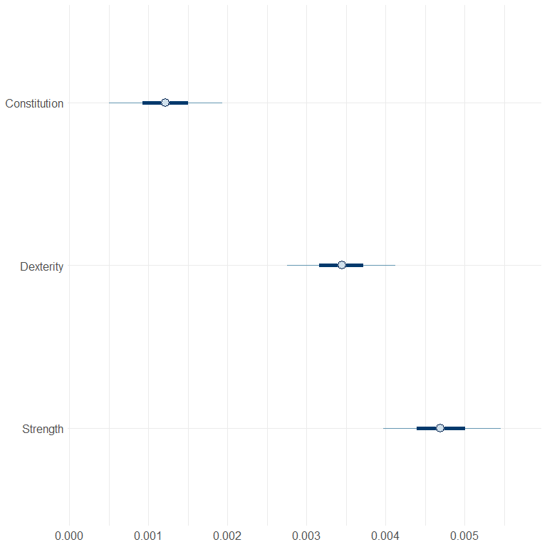
#10. What’s this! A special orichalcum coin has been found. Can this be the coin of pluck and luck? The one who carries the coin gains special luck. But alas, there are also coins of doom out there that look the same. In fact, 99% of orichalcum coins are actually coins of doom. When carried for a while, coins of doom cause great misery. The coin of pluck and luck will come up heads 55% of the time when flipped. The coin of doom will come up heads 45%. To test if this is the real coin of pluck and luck, you flip it 100 times. 50 of them come up heads. What is the probability that the coin is really the coin of pluck and luck given the data and assumptions?
n <- 100 # Total number of flips
k <- 50 # Number of heads observed
P_L <- 0.01 # P(L): Probability that the coin is the coin of pluck and luck
P_D <- 0.99 # P(D): Probability that the coin is a coin of doom
p_L_heads <- 0.55 # Probability of heads for the pluck and luck coin
p_D_heads <- 0.45 # Probability of heads for the doom coin
# P(H|L): Probability of observing k heads in n flips given it's the pluck and luck coin
P_H_given_L <- dbinom(k, size = n, prob = p_L_heads)
#P(H|D): Probability of observing k heads in n flips given it's the doom coin
P_H_given_D <- dbinom(k, size = n, prob = p_D_heads)
numerator <- P_H_given_L * P_L
denominator <- (P_H_given_L * P_L) + (P_H_given_D * P_D)
P_L_given_H <- numerator / denominator
P_L_given_H
## [1] 0.01
#The probability that the coin is really the coin of pluck and luck is: 0.01
#approximately 1%
#discard that coin!

